INTRODUCTION:

**PROJECT NAME: HERO’S OF ZARB-E-AZB**

*MEMBERS NAME: JAWERIA ASIF (9442)*

*JAVERIA HASSAN(9517)*

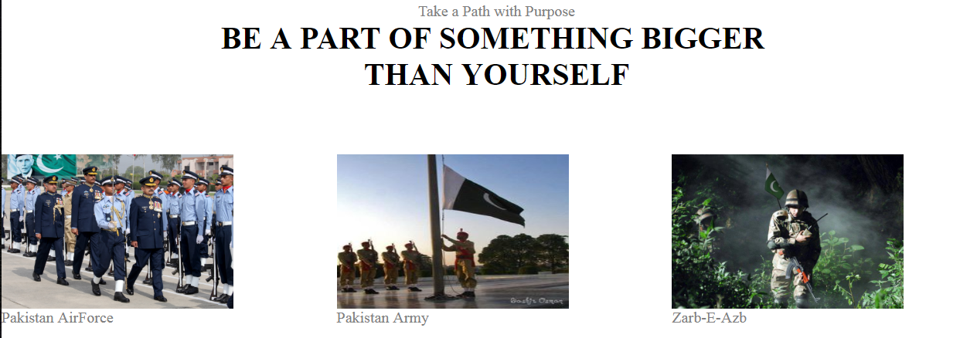

*LECTURER OF IICT (THEORY): SIR FAISAL AHMED*

*INSTRUCTOR OF IICT (LAB): SIR HAFIZ WAQAS*

*CLASS ID: 66207*

***TABLE OF CONTENTS***

* PROPOSED WEBSITE OF REAL HERO’S OF PAKISTAN
* *Proposed Website Design.*
* *Proposed Online Registration.*
* *Proposed Online forms to join ‘PAK ARMY FESTIVAL’.*
* *Proposed One Website that contains All Information*

*About Zarb-E-Azb Operation And Martyrs Of Zarb-e-Azb.*

*TOOLS & TECHNOLOGIES*

* HTML (HYPER TEXT MARKUP LANGUAGE)
* CSS (Cascade Styling Sheet)
* JAVA SCRIPT (for Login Page)

WEB PAGES CONSIST OF:

|  |  |
| --- | --- |
| Home | Timeline |
| Yearly Progress | Global |
| Gallery | Documentaries |
| International | Zarb-e-Azb |
| History | Martyr’s |
| Background | Final phase |
| Jinnah Airport Attack | Management of displaced civilians |
| Videos and Songs | Peace negotiation |
| press releases | Contact us |
| Success Ratio | Registration page |

A VIEW TO ALL PAGES

OF OUR WEBSITE THE HERO’S OF ZARB-E-AZB





INTRODUCTION:

A website is a term that describes a collection of web pages, media files and other digital assets that are all combined with the URL. An ARMY website has turned out extremely essential. It is important that every individual person has the knowledge of current situations facing by our country and the steps taken by the PAK ARMY and our government towards these problems.

OPERATION ZARB-E-AZB: was a [joint military](https://en.wikipedia.org/wiki/Joint_Chiefs_of_Staff_Committee) [offensive](https://en.wikipedia.org/wiki/Offensive_(military)) conducted by the [Pakistan Armed Forces](https://en.wikipedia.org/wiki/Pakistan_Armed_Forces) against various [militant](https://en.wikipedia.org/wiki/Militant_(word)) groups, including the Tehrik-i-Taliban Pakistan (TTP), the [Islamic Movement of Uzbekistan](https://en.wikipedia.org/wiki/Islamic_Movement_of_Uzbekistan), the [East Turkestan Islamic Movement](https://en.wikipedia.org/wiki/East_Turkestan_Islamic_Movement), Lashkar-e-Jhangvi, [al-Qaeda](https://en.wikipedia.org/wiki/Al-Qaeda), Jundallah and the Haqqani network.The operation was launched on 15 June 2014 in [North Waziristan](https://en.wikipedia.org/wiki/North_Waziristan) along the [Pakistan-Afghanistan border](https://en.wikipedia.org/wiki/Durand_Line) as a renewed effort against militancy in the wake of the [8 June attack on Jinnah International Airport](https://en.wikipedia.org/wiki/2014_Jinnah_International_Airport_attack) in Karachi, for which the TTP and the IMU claimed responsibility.As of 14 July 2014, the operation [internally displaced](https://en.wikipedia.org/wiki/Internally_displaced_person) about 929,859 people belonging to 80,302 families from North Waziristan.

Part of the [war in North-West Pakistan](https://en.wikipedia.org/wiki/War_in_North-West_Pakistan), up to 30,000 Pakistani soldiers were involved in Zarb-e-Azb, described as a "comprehensive operation" to flush out all foreign and local militants hiding in North Waziristan. The operation has received widespread support from the Pakistani political, defense and civilian sectors. As a consequence, the overall security situation improved and terrorist attacks in Pakistan dropped to a six-year low since 2008.

Zarb-e-Azb was followed by [Operation HYPERLINK "https://en.wikipedia.org/wiki/Operation_Radd-ul-Fasaad"Radd-ul-Fasaad](https://en.wikipedia.org/wiki/Operation_Radd-ul-Fasaad) which began in February 2017, following resurgence in terrorist incidents.

*A VIEW TO HOME PAGE*

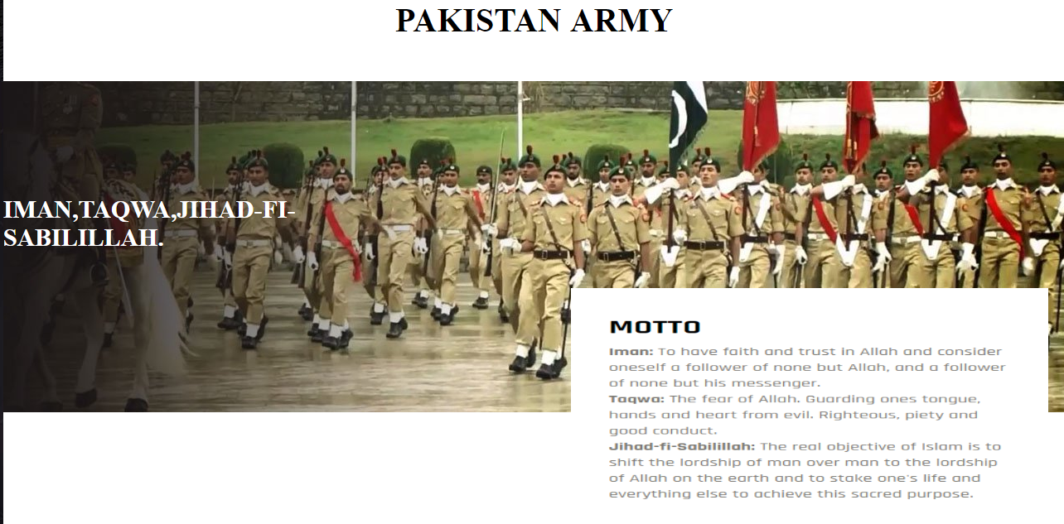

*A VIEW TO YEARLY PROGRESS:*

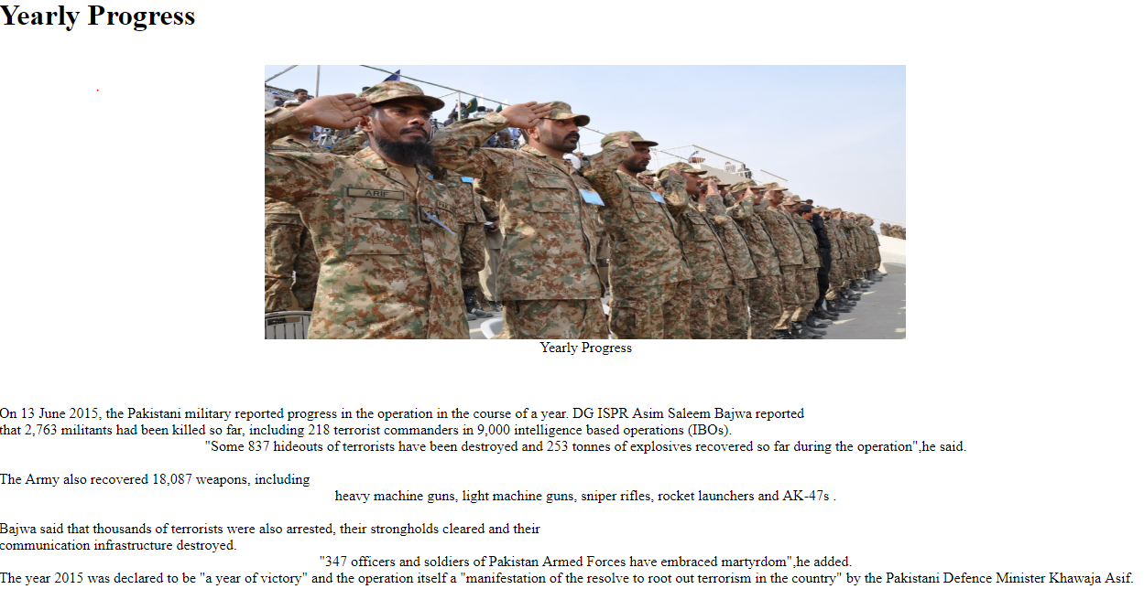

*A VIEW TO GALLERY:*

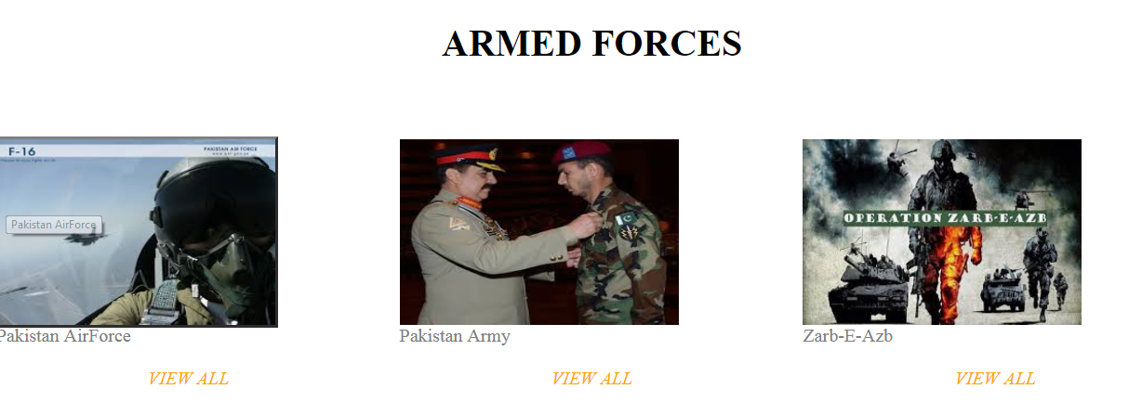

*A VIEW TO ARMY SONGS:*

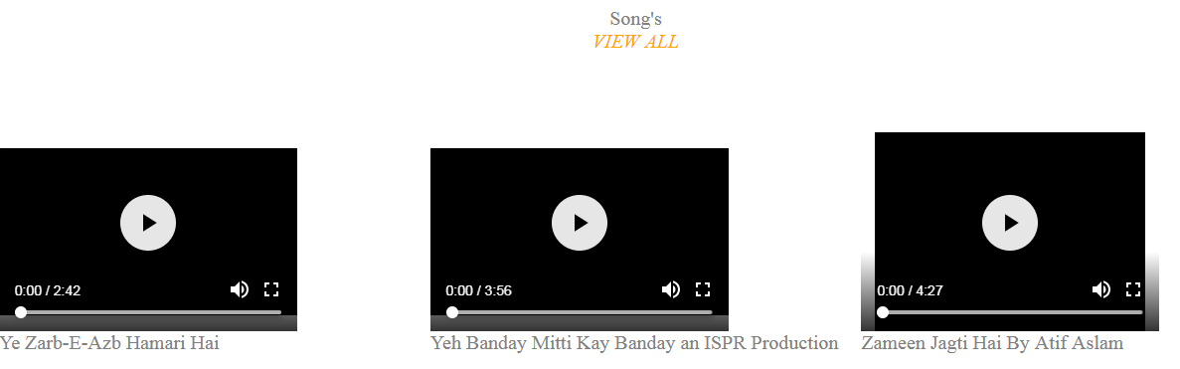

*A VIEW TO ARMY DoCUMENTARIES*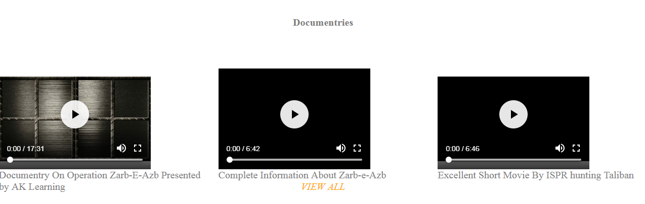

*A VIEW TO PAGE “OUR REAL HERO’S.”*

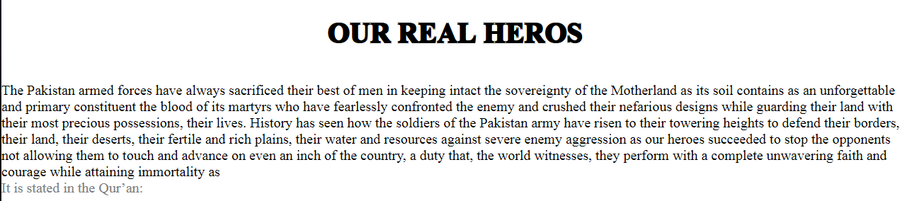

*A VIEW TO PAGE CONTACT US:*

The Contact Us one page contains Details About Army Festival Which Is organizing in Jinnah Ground Karachi.

This page has a Link of Registration form For joining army festival.

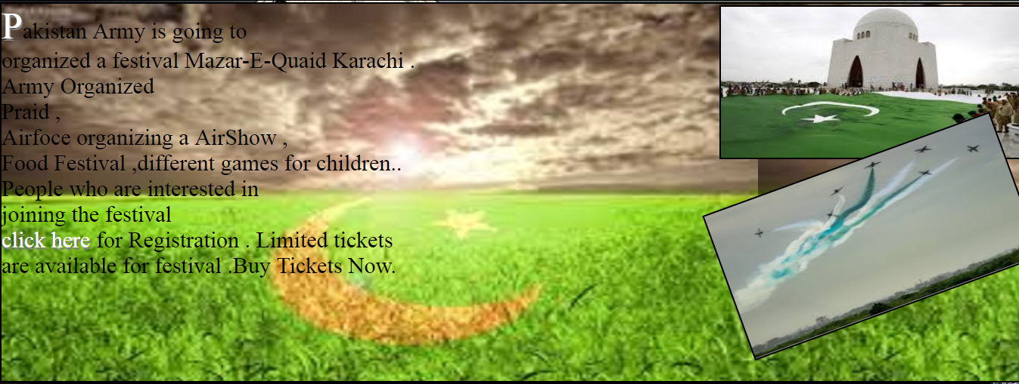

*A vIEW TOWARS Success Ratio OF ZARB-E-AzB*

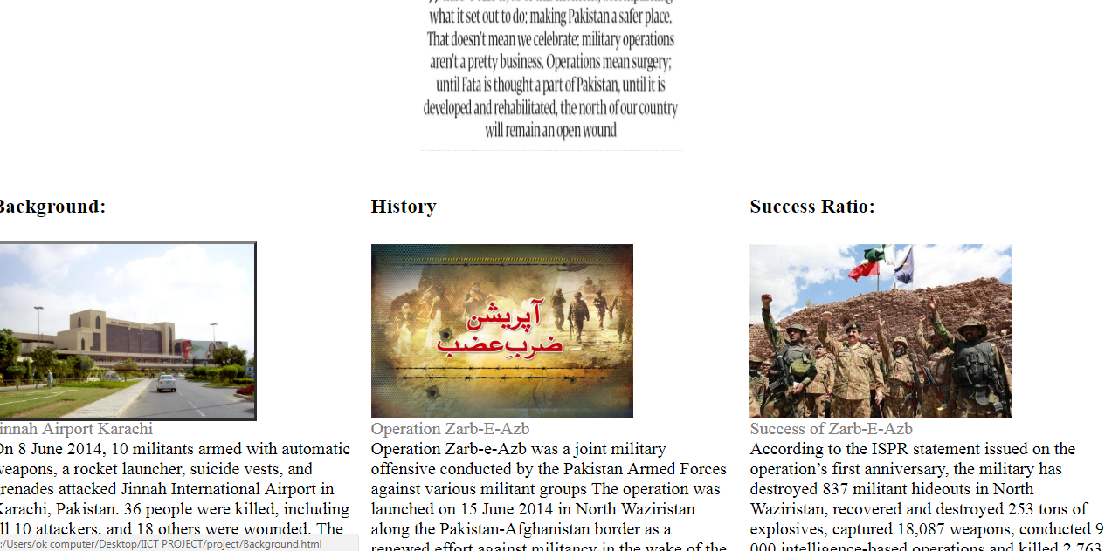

**PRESS RELEASES OF OPERATION ZARB-E-AZB**

*First Press Release*

*1 Year Press Release*

*Final Press Release*

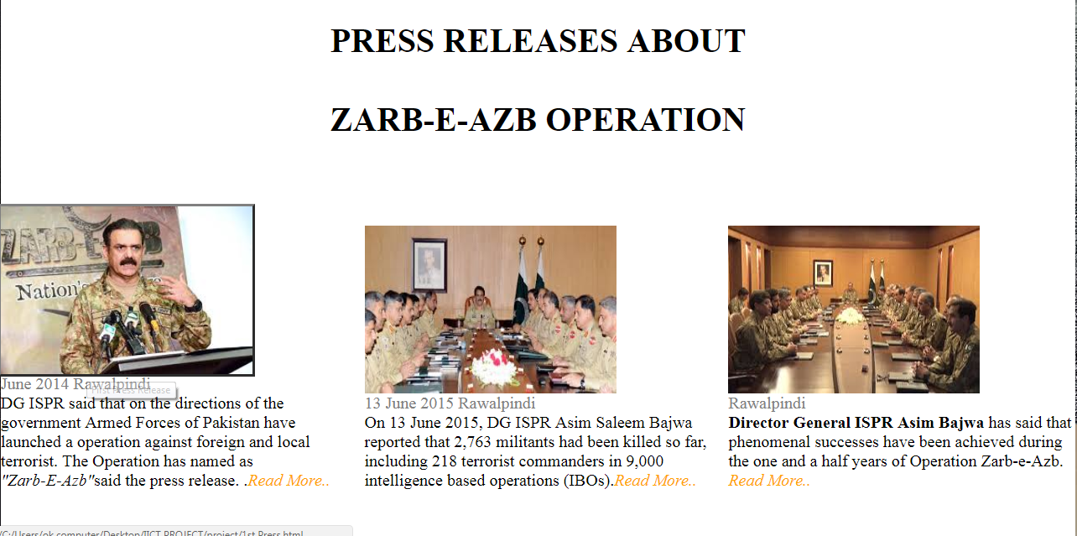

**A VIEW TO PAGE Zarb-e-Azb Operation**

* *Background*
* *Zarb-e-Azb History*

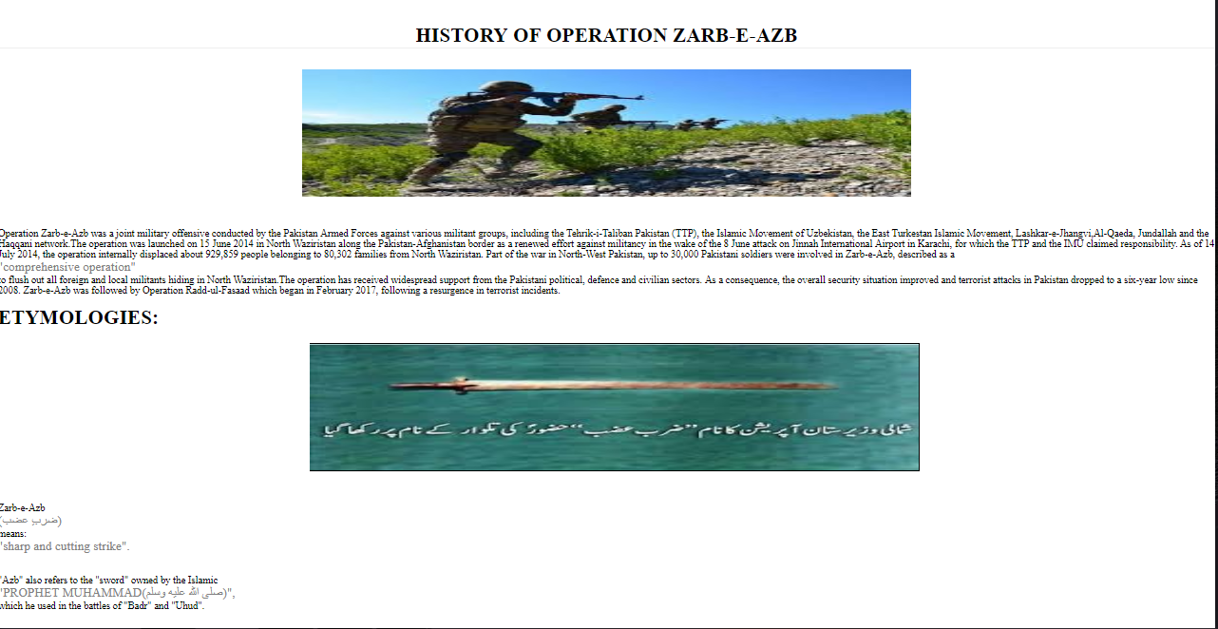

*LINKED OF PAGES VIA PICTURES:*

Here, we have link the pages so that if a user clicks on the picture he reached his desired page by clicking and can get more information

According to his need and as he want to

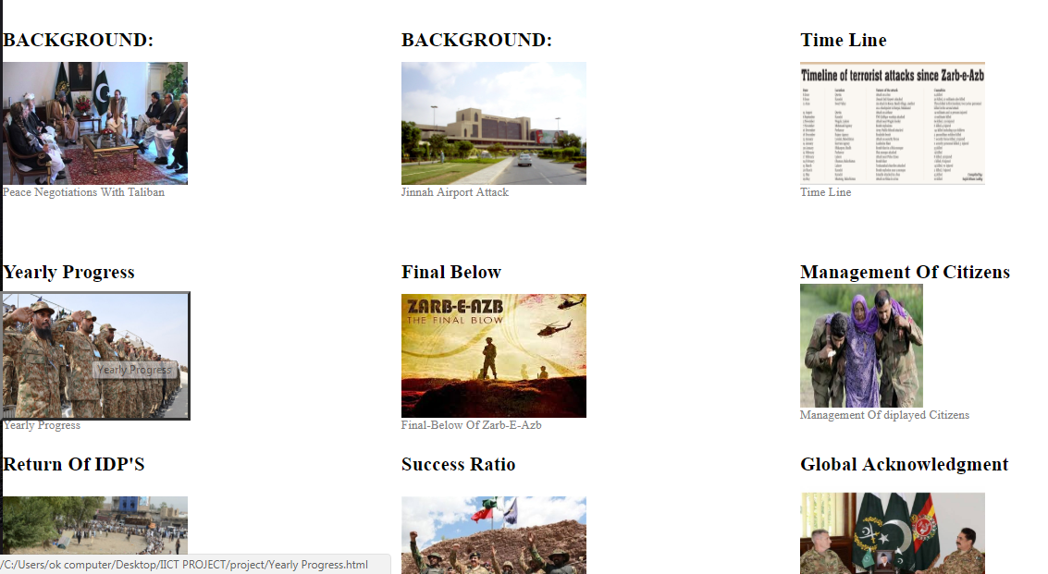

REGISTRATION FORM:

In registration Form user can register him for festival. In registration Form We Uses hover span buttons. We use html, java and css

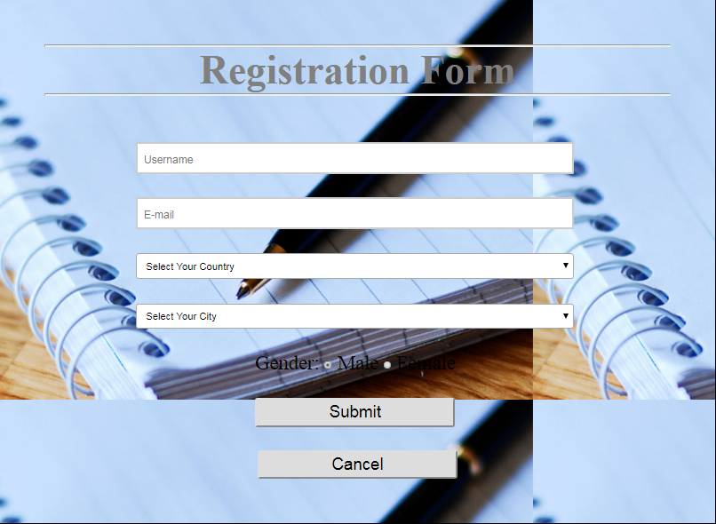

A VIEW TOWARDS JINNAH AIRPORT ATTACK

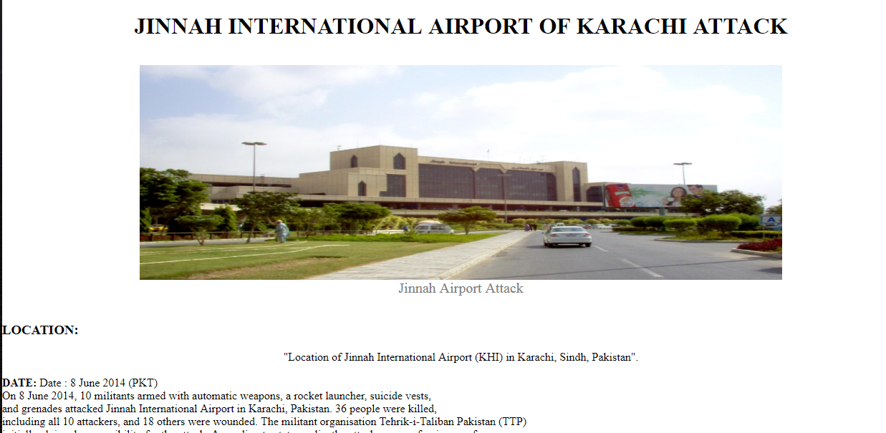**A VIEW TOWARDS Martyrs Of Zarb-e-Azb**

* *Maj. Akaash Rabbani*
* *Capt. AsfandYar Bukhari*
* *Lt. Abdul Moeed*
* *Capt.Umair*
* *Maj. Wasif*
* *Capt. Mujahid*

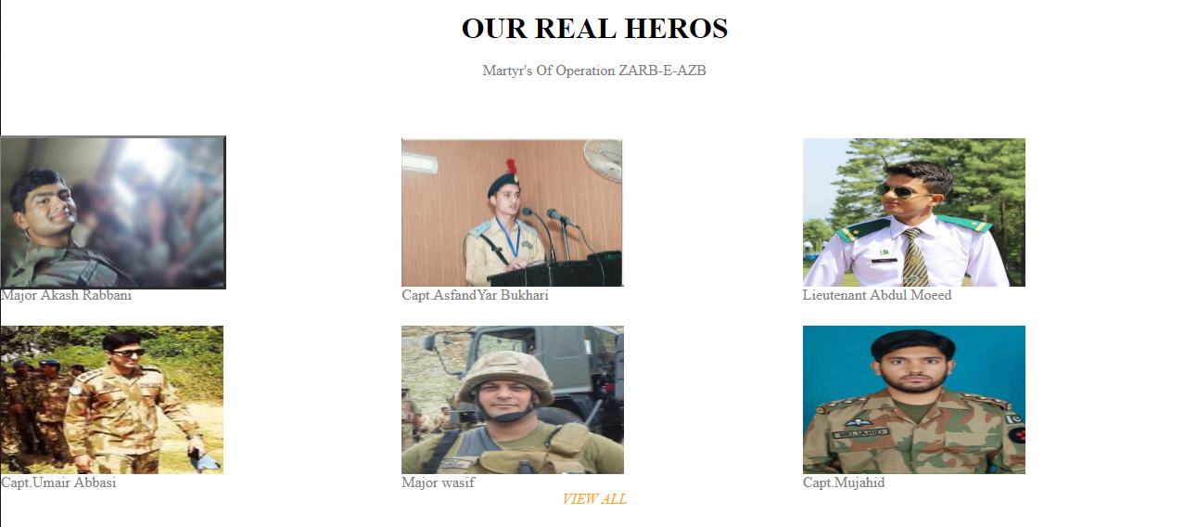

TAKE A VIEW ON PICTURES OF OUR WEBSITE

PICTURES ***IN AKAASH RABBANI PAGE***

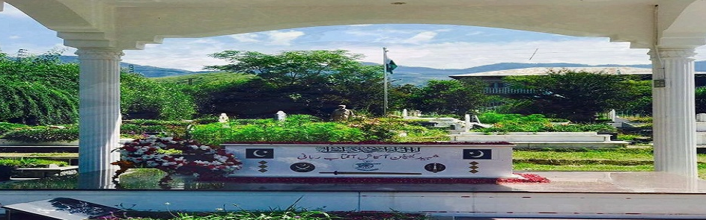

PICTURES ***IN CAPT. ASFANDYAR BUKHARI PAGE***

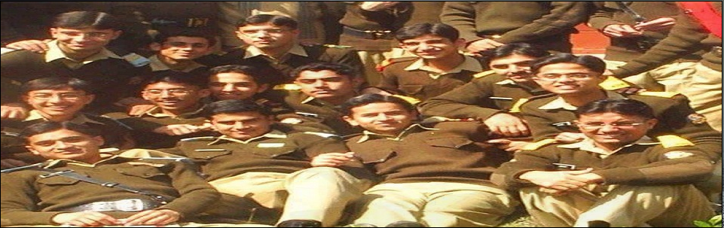

PICTURES ***IN LT.ABDUL MOEED PAGE***

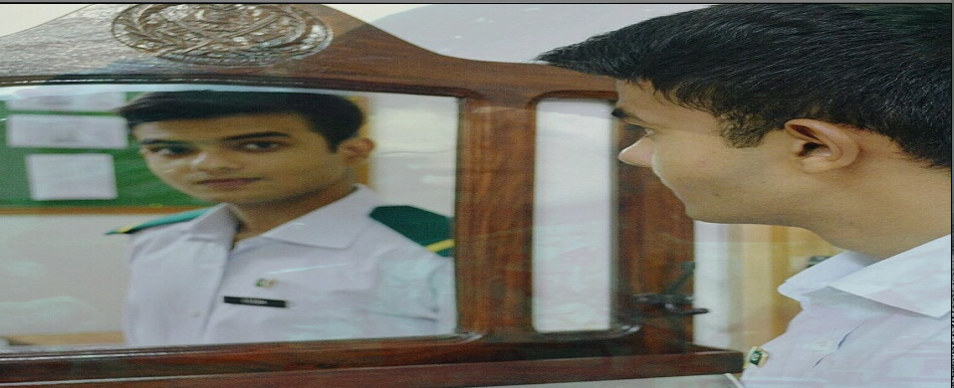

NEWS AND EVENTS

This is the latest way of displaying news feeds in home page we displaying the latest news that Army organizing a festival in Karachi so there is current news at our home page which is linked to its complete informative page.

**HOME PAGE:**

Our Home page contains search bar at top .we insert an auto play video song related to Zarb-e-Azb.

A view TOWARDS Coding of Home Page

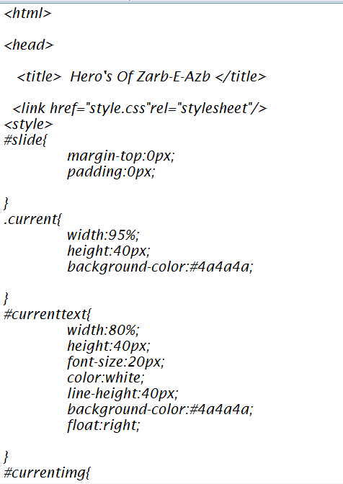

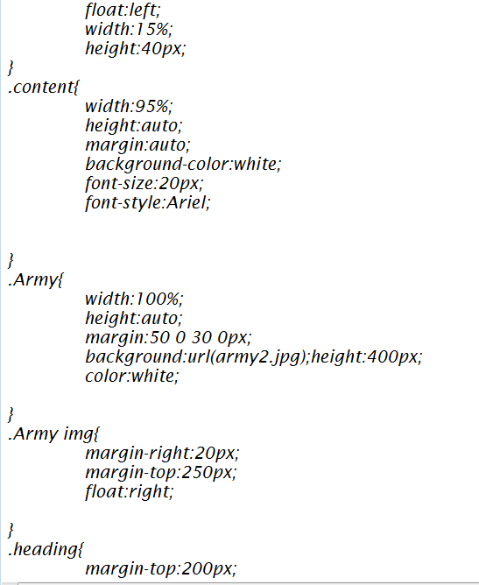

Following are the main tabs in Home Page

**Current News**

We use ***Navigation Bar*** which has following links. 

1. Home
2. Gallery
3. Martyrs
4. Zarb-e-Azb
5. Contact Us

Style Page Coding:

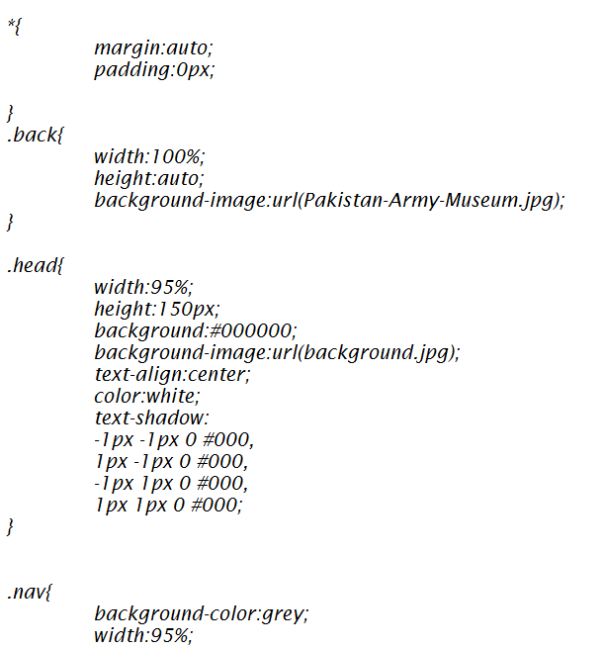

FOOTER

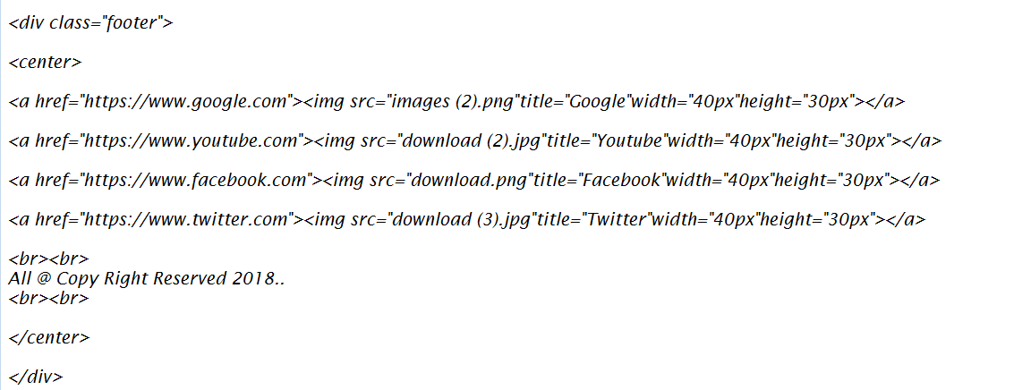

This Footer Contains The Copyright Notice And Social Media Sites Links.Such As Google,Facebook,Youtube And Twitter.

